2014

Robot framework for windows
installation instructions
Version 2.3. August 26, 2014
This document describes the installation of Robot Framework on the Windows platform. The document includes installation of certain packages that are required to execute the scripts created using Robot Framework and the RIDE IDE (Integrated Development Environment).

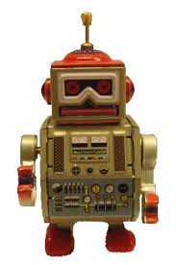

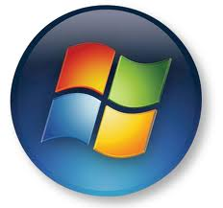

Version History
Date | Version | Author | Comments
3/17/2014 | 1.3 | Rich Paschburg | Updated with Optional Libraries
5/7/2014 | 2.0 | Raja Shekhar Reddy | Updated with Mabot Installation
5/8/2014 | 2.1 | Sandesha Thandra | Updated Mabot Installation section
5/19/2014 | 2.2 | Rich Paschburg | Added another method to _element.py
8/26/2015 | 2.3 | Rich Paschburg | Must install pywin32 from command interpreter.
01/04/2016 | 3.0 | Kishore Chava | Adding Desired Capabilities for Chrome Browser

Table of Contents
Version History 1
Installation of Robot Framework 4
Preconditions 4
Python 4
wxPython 5
Robot Framework 5
Installation of PIP 6
RIDE 7
Selenium2Library 8
AutoItLibrary 8
Web Drivers 9
Subversion and Tortoise 10
Start-Up 10
Optional Libraries 11
Optional Keywords added to Selenium2Library 12
Adding Desired Capabilities for Chrome Browser 14
Installation and use of Mabot 15
Mabot Installation 15
Using Mabot 16
Designing manual steps 17
Executing manual steps 17
Combining automation and manual test results 18

Installation of Robot Framework

Preconditions

Python
RIDE runs only on the regular Python, not on Jython or IronPython. Python 2.6 is the minimum version. These instructions refer to Python 2.7. Notice that similarly as Robot Framework, RIDE does not yet support Python 3.
Download and install Python 2.7.* from http://python.org. Go to the Python download page and choose a Windows x86 MSI Installer. Choose 32 bit Python (“x86”), not 64 bit, to be compatible with the AutoItLibrary. Note that 32 bit Python will run properly on a 64 bit system.
A quick link is: http://python.org/download/releases/2.7.6/, Choose defaults when you run python-2.7.6.msi.
Setting Environment Variables
- Navigate to Computer ‣ Properties ‣ Advanced system settings‣ Environment Variables
- Click on “new” to add an environment System variable PYTHON_HOME and set the value as “C:\Python27” (refer to below screenshot)
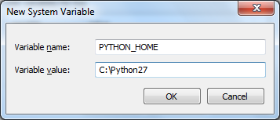
- Add “%PYTHON_HOME%;” and “%PYTHON_HOME%\Scripts;” to your system ‘Path’. Ensure that there is a “;” at the beginning and end of the new entries in the path (unless it is the first or last entry). Refer to the screenshot below.
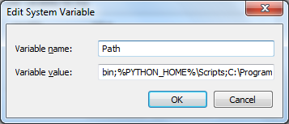
To verify if Python is correctly installed on your machine, run the below command in a command (cmd) window.
Python --version
If you get the response as shown in the snapshot below, it means Python is installed in your system. (This install was for Python 2.7.5.)
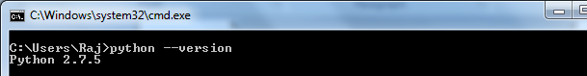

wxPython
RIDE's GUI is implemented using the wxPython toolkit. Only wxPython with Unicode support is officially supported. (Recent versions of wxPython have Unicode support.) The ANSI version of wxPython is not supported. The recommended wxPython version is 2.8.12.1.
Download an appropriate installer (such as wxPython2.8-win32-unicode-2.8.12.1-py27.exe) from the SourceForge project page at http://sourceforge.net/projects/wxpython/files/wxPython/2.8.12.1/ and run the installer using default choices.

Robot Framework
There are multiple ways to install Robot Framework. You can install Robot Framework from source, via Windows installers or through Python package managers. The following installation steps are via the Python package manager PIP.

Installation of PIP
pip requires setuptools, so setuptools has to be installed first, before pip can be installed.
To install setuptools from scratch:
- Download ez_setup.py. Please follow the download instructions below:
  - There is a location of ez_setup.py at https://bitbucket.org/pypa/setuptools/raw/bootstrap/ez_setup.py.
  - Copy the code and save it in a file called ez_setup.py. I recommend putting the file in a directory such as C:\Python27\Scripts.
  - Navigate to the directory where you have placed ez_setup.py.
- Then run the following (which may require administrator access) from the folder that contains ez_setup.py using a command window:
python ez_setup.py
- Verify if the ‘setuptools’ are correctly installed. Once the above py file is run, at the bottom of the command prompt, look for the below message. The version file may be more recent.
Output:
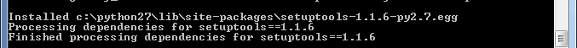
- Download get-pip.py. Please follow the download instructions below:
  - Navigate to http://www.pip-installer.org/en/latest/installing.html
  - Right-click on get-pip.py and click on ‘Save link as’
  - Download the file. . I recommend putting the file in a directory such as C:\Python27\Scripts.
- Then run the following (which may require administrator access) from the folder that contains get-pip.py using a command window, to install the latest version of pip:
python get-pip.py
- To verify if PIP is correctly installed in your machine, run the below command. You should see the output as shown below, although perhaps with a newer version number.
pip --version
Output:
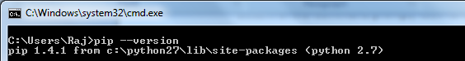
- Then get the latest install of setuptools, by running the below command
pip install --upgrade setuptools
- Now, install Robot Framework by running the below command

pip install robotframework

If you experience a problem with pip use “easy_install robotframework”.
- After a successful installation of Robot Framework you should be able to execute the following command on the command prompt. Your version number may be newer.
pybot --version
Output:
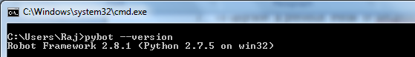

RIDE
RIDE can be installed with pip using the below command:
pip install robotframework-ride

You can also create a desktop shortcut for Ride. I got the desktop icon by again going through the steps for installing Ride, this time using the robotframework-ride-1.2.1.win32.exe file from the robotframework-ride project in code.google.com. I selected the option to get the icon. The install returned an error. But the Ride icon appeared on the desktop. I then modified the Target for the Ride icon (in the properties) by replacing “C:\Users\<my user name>\” by “C:\Python27\”. This approach is a bit round-about, but it does the job of getting the RIDE icon on the dashboard.

Selenium2Library
Selenium2Library can be installed using pip. The advantage of installing it via pip is that it will automatically install its dependencies.
You can install Selenium2Library using pip, with the following command
pip install robotframework-selenium2library

AutoItLibrary
Tests can use the native Windows GUI testing library AutoItLibrary to manipulate the mouse. These tests will not be available for Mac or Linux.
AutoItLibrary documentation mentions a dependency on Python for Windows Extension, pywin32. That project is in sourceforge. Please follow the below instructions to download and install ‘pywin32’.
- Go to http://sourceforge.net/projects/pywin32/files/pywin32/
- Choose the folder for Build 218 or later.
- Click on ‘README.txt’ to understand your system configuration. Note that since we installed 32 bit Python, the 32 bit version of Python for Windows extension has to be used.
- Click on the link in the web page to download the appropriate pywin32 when you have 32-bit Python27 installed:
- Open a command window using the “Run as Administrator” option. Browse to the download location of the file, and run the .exe file to install pywin32. You could run the file by typing .\pywin32-218.win32-py2.7.exe.
  - Reference: http://stackoverflow.com/questions/11106281/error-installing-and-running-pywin32-2-7
After installing the dependency libraries, download and install ‘AutoItLibrary’ by following the below instructions
- Go to https://code.google.com/p/robotframework-autoitlibrary/
- Click on ‘Downloads’ and follow the links to download the ‘AutoItLibrary-1.1.zip’
- To install AutoItLibrary, unzip the downloaded source release file into a directory on your PC, open a command window in that directory, and type:
python setup.py install

NOTE: In Windows Vista and Windows 7 you must do this installation as Administrator.
The installation creates a folder, either C:\RobotFramework\Extensions\AutoItLibrary or C:\Python27\Lib\site-packages\AutoItLibrary, on your PC and puts various files into this directory folder.

Web Drivers
The Robot Framework scripts can be executed on a Firefox browser by default without specifically adding a web driver. However, executing scripts on Internet Explorer and Google Chrome requires web drivers to be downloaded and placed in the Path environment variable.
- Download IE driver server. Use the 32 bit version (Win32) as it is more stable. Get the server from http://selenium-release.storage.googleapis.com/index.html. Use the directory with the latest version number. The file’s name will be “IEDriverServer_Win32_2.40.0.zip” or a later version. Extract the file to get “IEDriverServer.exe”.
- Download the Chrome driver. I suggest using the 32 bit version in case there are compatibility issues. You can get the server from the directory http://chromedriver.storage.googleapis.com/index.html?path=2.9/. The zip file name is “chromedriver_win32.zip”. Extract the file to get “chromedriver.exe”.
- Place the two drivers in the “C:\Python27” folder or in some other folder in your Path. I recommend that you put the two drivers into a new folder called “C:\DriverServers” and then add “C:\DriverServers” to the Path environmental variable.
- If you have not done so, install Chrome and Firefox. (Internet Explorer comes with Windows.)

Subversion and Tortoise
Install Tortoise and Subversion if you use a Subversion (SVN) code repository. Select an appropriate windows installer which best suites your system requirements. For a 64 bit Windows machine TortoiseSVN-1.8.5.25224-x64-svn-1.8.8.msi can be used. This version of Tortoise is linked against the Subversion library 1.8.8.
Go to http://tortoisesvn.net/downloads.html to download the Tortoise Subversion client for 32-bit or 64-bit Windows.
Go to http://subversion.apache.org/packages.html#windows for information on installing a Subversion library.

Start-Up
After a successful installation RIDE can be started from the command line by running ride.py. If a small window appears, simply resize it. If you installed the RIDE icon on the desktop, click (or double click) on it to start RIDE.

Optional Libraries
There are several libraries that can be useful for test development:
- xlrd: To manipulate Excel files:
  - pip install xlrd
- pytz: To work with time zones
  - We had problems with pip, so you may have to use “easy_install pytz”
- python-dateutil: to get extensions to the standard Python datetime module.
  - pip install python-dateutil
- Other library files may be needed for your installation.

Optional Keywords added to Selenium2Library
There is a file called “_element.py” which may require additional keywords to be added. For example, if the test suite uses the keyword “Mouse Scroll” then the “Mouse Scroll” keyword listed below should be added to the “_element.py” file. The simplest approach is to copy each of these keywords into _element.py, since you may not know which keywords are used.
“_element.py” is typically located in “C:\Python27\Lib\site-packages\Selenium2Library\keywords\_element.py”.
The lines to add are:
def mouse_click(self):
"""Simulates moving mouse away from the element specified by `locator`.

Key attributes for arbitrary elements are `id` and `name`. See
`introduction` for details about locating elements.
"""
ActionChains(self._current_browser()).move_by_offset(1042, 840).click()

def mouse_scroll(self, locator):
"""Simulates releasing the left mouse button on the element specified by `locator`.

Key attributes for arbitrary elements are `id` and `name`. See
`introduction` for details about locating elements.
"""
self._info("Simulating Mouse Up on element '%s'" % locator)
element = self._element_find(locator, True, False)
if element is None:
raise AssertionError("ERROR: Element %s not found." % (locator))
size = element.size
offsetx = (size['width'] / 2) + 1
offsety = (size['height'] / 2) + 1
# the following is one long line indented the same as the above lines
ActionChains(self._current_browser()).move_to_element(element).click_and_hold(element).move_by_offset(offsetx,offsety).release(element).perform()
# the above is one long line indented the same as the other lines

def mouse_release(self, locator):
"""Simulates releasing the left mouse button on the element specified by `locator`.

Key attributes for arbitrary elements are `id` and `name`. See
`introduction` for details about locating elements.
"""
#self._info("Simulating Mouse Up on element '%s'" % locator)
element = self._element_find(locator, True, False)
if element is None:
raise AssertionError("ERROR: Element %s not found." % (locator))
ActionChains(self._current_browser()).release(element)

def key_hold(self,keyvalue):
"""Simulates pressing the left mouse button.
"""
ActionChains(self._current_browser()).key_down(keyvalue).perform()

Adding Desired Capabilities for Chrome Browser :

Add The below keyword(get_chrome_browser_options) In CommonLibrary.py file for Handling chrome options.For this One no need to install any additional packages to implementing the keyword.

Import Statements :

from selenium import webdriver

from selenium.webdriver.chrome.options import Options

from selenium.webdriver.common.desired_capabilities import DesiredCapabilities

from sys import exit

Keyword :

def get_chrome_browser_options(self):

dictionary= {'profile.default_content_settings.popups':'0'}

chrome_options = Options()

chrome_options.add_argument("--disable-extensions")

chrome_options.add_argument("test-type")

#chrome_options.add_argument("-incognito")

chrome_options.add_argument("--disable-popup-blocking")

chrome_options=chrome_options

return chrome_options

Installation and use of Mabot
Mabot is used to run manual tests. The results of the tests can be integrated into the results from an automated run using Robot Framework.

Mabot Installation
- Prerequisites: Install Python
- Download and install mabot.exe file from the location
http://code.google.com/p/robotframework-mabot/downloads/list
- Install mabot-0.10.win-amd64.exe for windows 64 bit version OS.
- Install mabot-0.10.win32.exe for windows 32 bit version OS.
Reference URL: http://code.google.com/p/robotframework-mabot/wiki/UserGuide
- Create a directory structure for Automation Test Cases and Manual Test cases for any sample Project. Please find the below screen shot for project directory creation.
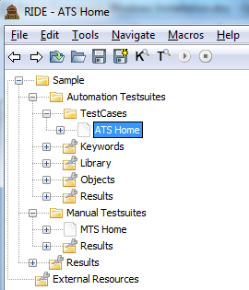

Using Mabot

Designing manual steps
- Open Ride.py as editor to design manual test case. Enter ride.py from command prompt or double-click the RIDE shortcut placed at desktop.
- Open the project using File>>Open Directory option from Ride. Navigate to the project directory structure to open the project.
- Create a test suite, Select Folder (Manual Testsuites) and right click. From the context menu select the "New Suite" option. Enter the suite name and click the OK button.
- Select the newly created test suite and right click. Select "New test case" option from the context menu. Enter the test case name and click the OK button.
- Use Documentation to provide a description of the test.
- A tabular format is displayed. Use the first column for Step Details, the second column for Test Data, and the third column for Expected Results.
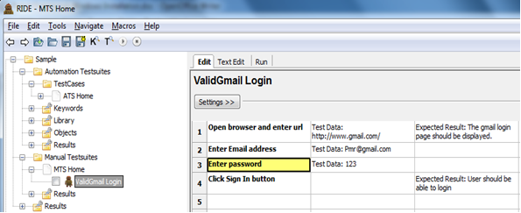

Executing manual steps
- Open a command prompt, enter mabot command and click enter.
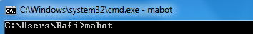
- The Mabot UI is displayed. Using "File >> Open Dir", open the manual test suite to execute. Refer to the screenshot below.
- Execute the steps described in the manual test steps and update the status accordingly. In the “Message” field enter the Actual Results.
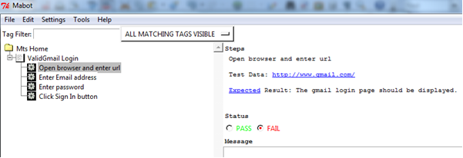

- As shown in the above screen shot, click on each step of the Test Case. Initially the 'status' section shows Fail. After running the manual test case, update the status to Pass or Fail as appropriate. If the test fails, explain what was observed in the “Message” text box. Store the results into the directory location for the user’s tests.
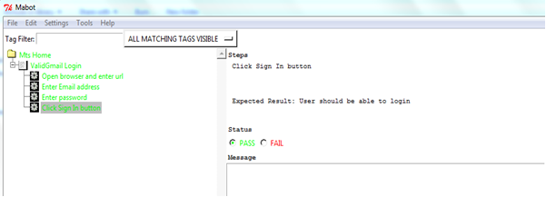
- Complete the manual test suite execution. On completion save the results by selecting the "File>Save As" option, and enter the file path for the result of the manual execution and the name of the file. Use an .xml extension.

Combining automation and manual test results
  - Save the manual test case execution results from Mabot to the appropriate directory and using an extension of .xml.
  - Execute automation test scripts with the option to display the results in xml format.
[Project dir]>pybot -o [OutPutDirectoryLocation]\filenamexxx.xml [TestSuiteName].txt

  - Run rebot command to combine Automated and Manual test execution results.
>rebot --name Combined AutomationOutput_filename.xml manual__output_filename.xml

  - The merged results file looks like the following:
